**CSC 455 – Databases for Large Scale Analytics**

**Assignment 3**

**Due Wednesday, May 9th**

Part 1

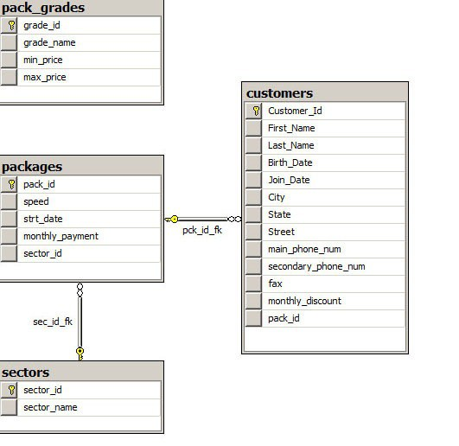

1. Cities and the average monthly discount (Customers table) –

* Display the city and the average monthly discount for each city
* Display the city and the average monthly discount for each city, only for the customers whose monthly discount is greater than 20

1. States and the lowest monthly discount (Customers table) –

* Display the state and the lowest monthly discount for each state.
* Display the state and lowest monthly discount for each state, only for states where the lowest monthly discount is greater than 10

1. The number of customer in each internet package (Customers table) –

* Display the package number and the number of customers for each package number.
* Modify the query to display the package number and number of customers for each package number, only for the customers whose monthly discount is greater than 20.
* Modify the query to display the package number and number of customers for each package number, only for the packages with more than 100 customers.

1. Customers and internet packages (Customers & Packages tables) –

* Write a query to display first name, last name, package number and internet speed for all customers.
* Write a query to display first name, last name, package number and internet speed for all customers whose package number equals 22 or 27. Order the query in ascending order by last name.

1. Internet packages and sectors –

* Display the package number, internet speed, monthly payment and sector name for all packages (Packages and Sectors tables).
* Display the customer name, package number, internet speed, monthly payment and sector name for all customers (Customers, Packages and Sectors tables).
* Display the customer name, package number, internet speed, monthly payment and sector name for all customers in the business sector (Customers, Packages and Sectorstables).

1. Customers and internet packages (Customers and Packages tables)

* Display the first name, last name, internet speed and monthly payment for all customers. Use INNER JOIN to solve this exercise.
* Modify last query to display all customers, including those without any internet package.
* Modify last query to display all packages, including those without any customers.
* Modify last query to display all packages and all customers.

Part 2

1. Create the below tables using SQL.
2. Create the Person table. Person(person_id,first_name,last_name)

Primary Key: person_id; All the other fields are required.

1. Create the Building table. Building (building_id,building_name)

Primary Key: building_id; All the other fields are required.

1. Create the Room table. Room(room_id, room_number, building_id, capacity)

Primary Key: room_id; All the other fields are required.

1. Create the Meeting table. Meeting (meeting_id,room_id,meeting_start,meeting_end)

Primary Key: meeting_id; ; All the other fields are required.

1. Create the Person-Meeting intersection table. Person_meeting(person_id,meeting_id)

Primary Key: person_id, meeting_id

1. Insert the below data in the Person table

(Tom, Hanks)

(Anne", Hathaway)

(Tom, Cruise)

(Meryl", Streep)

(Chris, Pratt)

(Halle, Berry)

(Robert, De Niro)

(Julia, "Roberts")

(Denzel, "Washington)

(Melissa, McCarthy)

1. Insert the below data in the Building table

(Headquarters)

(Main Street Building)

1. Insert the below data in the Room table

(room_number, building_id, capacity)

(100, 1, 5)

(200, 1, 4)

(300, 1, 10)

(10, 2, 4)

(20, 2, 4)

1. Insert the below data in meeting table

meeting (room_id, meeting_start, meeting_end)

(1, 2016-12-25 09:00:00, 2016-12-25 10:00:00)

(1, 2016-12-25 10:00:00, 2016-12-25 12:00:00)

(1, 2016-12-25 11:00:00, 2016-12-25 12:00:00)

(2, 2016-12-25 09:00:00, 2016-12-25 10:00:00)

(4, 2016-12-25 09:00:00, 2016-12-25 10:00:00)

(5, 2016-12-25 14:00:00, 2016-12-25 16:00:00)

1. Insert the below data in person_meeting table

person_meeting (person_id, meeting_id)

(1, 1)

(10, 1)

(1, 2)

(2, 2)

(3, 2)

(4, 2)

(5, 2)

(6, 2)

(7, 2)

(8, 2)

(9, 3)

(10, 3)

(1, 4)

(2, 4)

(8, 5)

(9, 5)

(1, 6)

(2, 6)

(3, 6)

1. Find all the meetings that Tom Hanks has to attend
2. Find all the people that are attending meeting ID 2
3. Find all the people who have meetings in the Main Street building
4. Find the number of attendees for every meeting
5. Find All of the People that Have Meetings Only Before Dec. 25, 2016 at Noon Using INNER JOINs